US REBCO Production Information

- MetOx (Houston, Texas, USA)
- Production capability: >1,000 km of HTS tape per year in U.S.
- https://www.uh.edu/news-events/stories/2023/october-2023/10102023-doe-superconductivity-funding.php
‘By end of 2023, MetOx plans to open its new manufacturing facility and the first ever large-scale production line in the US capable of producing over 1000 km of HTS per year’

- HTS Inc / High Temperature Superconductors, Inc. (Santa Barbara, CA, USA)
- Production capacity: 1,200 km/year at 16 mm wire width.
- Also notes: “equivalent to 6,400 km/year at 4 mm width
- https://www.hitsuperconductors.com/about/
‘Our facility is capable of production of 1200 km per year of 16 mm wide (6,400 km at 4mm wide) wire with plans to increase production in the next 2 years. The 16mm wire can be laser slit to 12 and 4mm to meet fusion customers' needs.’

- SuperPower Inc. (Glenville, New York, USA)
- Production capacity: After Phase 1 expansion, tape production capacity doubled from ~120 km/yr to ~240 km/yr at 12 mm width.


- American Superconductor (AMSC)
- Do not provide a clearly quantified km/yr production figure in publicly citable sources

In total of approximately 2,400 km of REBCO annually produced in the states
$$2,400 \left[km\right]×0.1512 \left[\frac{kg}{km}\right]≅363\left[kg\right]$$
Approximately production of ~30 kg per month
[INVALID]

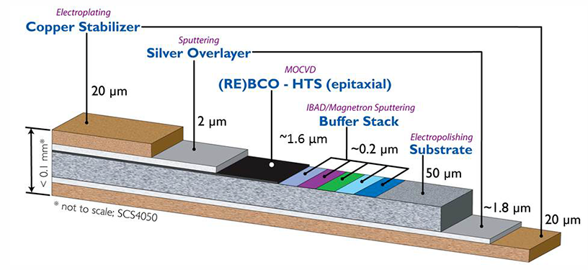
Architecture of REBCO:
REBCO tape, short for "Rare Earth Barium Copper Oxide tape," refers to a type of superconducting tape that is used in various applications, particularly in the field of high-temperature superconductivity.
This type of tape is based on the high-temperature superconducting material REBCO, which stands for Rare Earth Barium Copper Oxide.
REBCO materials are known for their ability to maintain superconductivity at relatively higher temperatures compared to traditional superconductors. It has four main layers, substrate, buffer layer, superconducting layer (REBCO), and Ag cap.
The REBCO material in usage (for REBCO tape) is actually very thin
- Thus, by multiplying the length of REBCO production with proper width & thickness, one could estimate the required amount of REBCO in terms of mass (kg).
From https://www.superpower-inc.com/specification.aspx
Substrate thickness | 50 µm, or 30 µm
Width | 12, 6, 4, 3, or 2 mm
For the time being, postulate thickness of 2 µm (for REBCO!) and width of 12 mm. Then, every 1km of REBCO material is equivalent to (density: 6.3 g/cc 6,300 kg/m³)
$$6,300 \left[\frac{kg}{m^{3}}\right]*1,000 \left[m\right]*2×{10}^{-6}\left[m\right]*12×{10}^{-3}\left[m\right]=0.1512 [kg]$$
[INVALID]

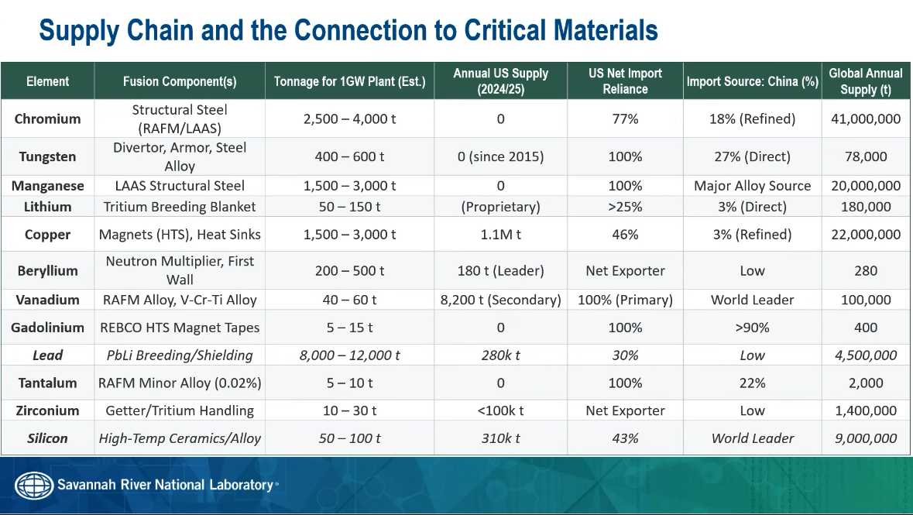
REBCO composition according to ‘PARATAN’ / THIS IS YBCO Thin Layer not the whole tape!
# This is basically YBCO for now
rebco = openmc.Material(name="REBCO tape")
rebco.set_density("g/cm3", 6.3)
rebco.add_element('Y', 7.6923076)
rebco.add_element('Ba', 15.3846153)
rebco.add_element('Cu', 23.0769230)
rebco.add_element('O', 53.8461538)

Newly Corrected REBCO related discussion: refer to the ppt (2026.03.24)

Market Growth Rate?
https://www.htfmarketintelligence.com/report/global-high-temperature-superconducting-wire-market
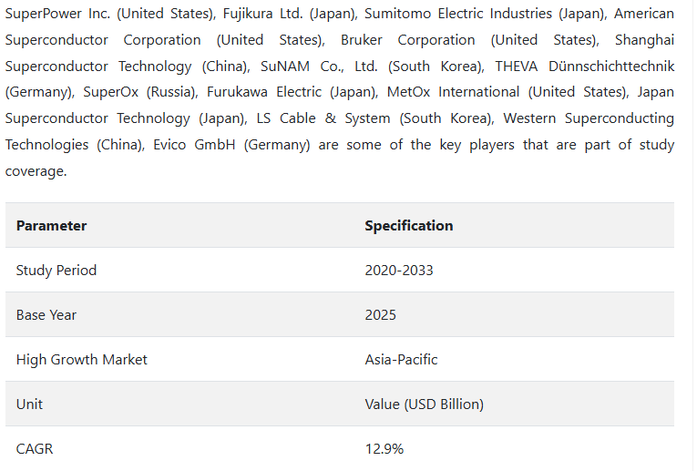
CAGR in the order of ~ 12%
(So, we can sweep between 10% to 15%)

